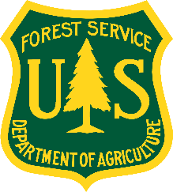Outreach for Two Permanent Research

Hydrologist GS-1315-12 Positions

The Northern Research Station is conducting a pre-vacancy announcement outreach for highly skilled and qualified candidates to fill **two permanent GS-1315-12 Research Hydrologist positions** with a duty station of either **Durham, NH or North Woodstock, NH**. This notification is being circulated to inform prospective applicants of this upcoming opportunity and to determine interest in the position. To express interest, please return this completed form and your resume to [john.campbell2@usda.gov](mailto:john.campbell2@usda.gov) via email by July 09, 2023. Please list the position you are interested in and your duty station preference on the form. Also indicate if you are eligible for any of the listed special hiring authorities.

# Northern Research Station

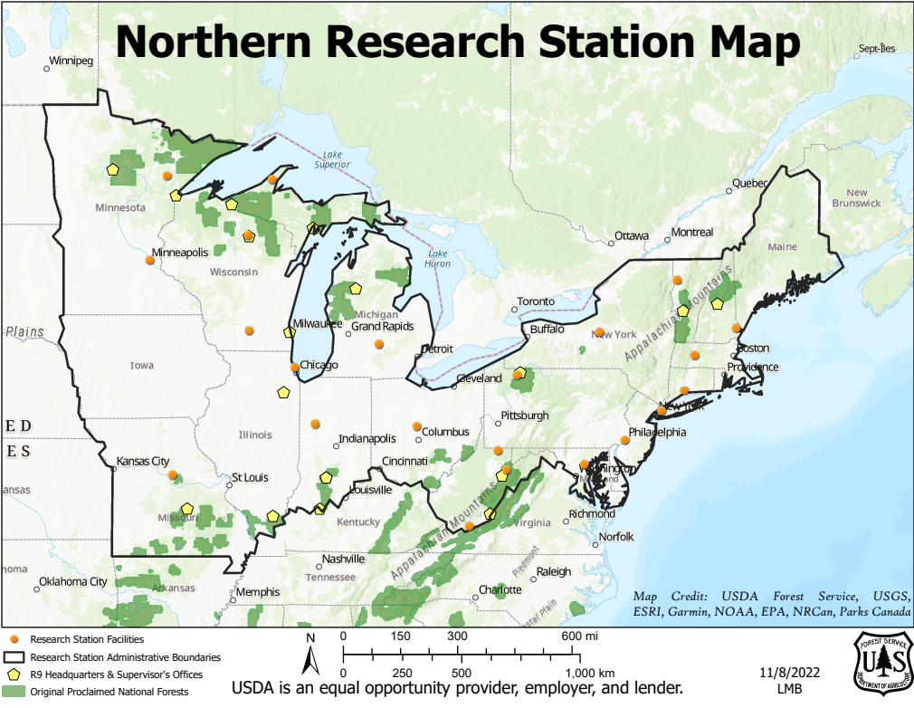

The USDA Forest Service’s Northern Research Station develops science that sheds light on how ecosystems ranging from forests to urban areas work and the challenges that threaten them. Learn more about the Northern Research Station by visiting <https://www.fs.usda.gov/research/nrs>.

## Positions

The positions are with the USDA Forest Service; Northern Research Station; Northern Forest Science and Applications Research Work Unit (NRS-7C). The mission of the Research Work Unit is to provide science and tools to strengthen northern forests and communities, now and in the future. One of the positions is a field hydrologist and the other is a spatial hydrologist with the following duties:

**Field Hydrologist** - The scientist will lead the long-term hydrological monitoring program at the Hubbard Brook Experimental Forest and conduct research and experiments that improve understanding of hydrological processes and watershed health in northern forest ecosystems.

### Major Duties:

* Measure basic hydrological processes such as interception, snowpack development and melt, transpiration, infiltration, groundwater recharge, and stream discharge.
* Identify and quantify streamwater sources, flowpaths, age and quality.
* Evaluate how disturbances affect the supply and quality of water.
* Develop management strategies to improve and maintain freshwater resources in the Northern Forest.
* Use a combination of long-term data and experiments to evaluate hydrological processes.
* Transfer research findings and supporting data to users through scientific and data publications, technical reports, presentations, workshops, and watershed and experimental forest tours.
* Supervise one or more positions as needed. In addition to formal supervisory responsibilities, the scientist will provide mentoring and oversight to Forest Service employees, post-docs, students, and other term and temporary employees on a variety of research projects.

**Spatial Hydrologist** - The scientist uses modeling and geospatial data analysis tools to improve understanding of large-scale, long-term hydrologic patterns and processes. The scientist integrates spatial information across multiple scales using observational and experimental techniques.

### Major Duties:

* Develop and improve models to predict the effects of disturbances such as land use and climate change on hydrology and biogeochemistry.
* Use modeling, remote sensing, and Geographic Information System (GIS) technologies to scale up hydrologic and biogeochemical processes in time and space (e.g., scaling from small watersheds to large basins and regions).
* Use models in applications that are relevant to land and water resource managers, such as flood forecasting, simulating snowpack and soil freezing, improving connectivity for aquatic organism passage.
* Use GIS software, scripting techniques, statistics, data mining, and modeling methodologies to produce, manipulate, analyze, and interpret geospatial and related datasets that contribute to understanding of the hydrologic cycle.
* Transfer research findings and supporting data to users through scientific and data publications, technical reports, presentations, workshops, and watershed and experimental forest tours.
* Supervise one or more positions as needed. In addition to formal supervisory responsibilities, the scientist will provide mentoring and oversight to Forest Service employees, post-docs, students, and other term and temporary employees on a variety of research projects.

## Duty Locations

***North Woodstock, NH*** (pop. 780) is in the heart of the White Mountains in central New Hampshire. The region is known for its warm hospitality, rich history, beautiful mountain scenery, wide variety of recreational activities, and four-season lifestyle. Cultural activities thrive, and nearby towns, such as Plymouth, offer concerts, plays, children’s activities, and church functions. North Woodstock and the towns around it are close enough to large cities such as Boston and Portland, ME for day trips.

***Durham, NH*** (pop. 15,490) offers the best of both worlds--breathtaking scenery and the slower pace of New England country and small-town life. With the seacoast city of Portsmouth, New Hampshire only 8 miles to the east, Boston, MA 1 hour to the south, and Portland, ME 1 hour to the north, residents can access the best in arts, culture, and sporting events. Durham is home to the University of New Hampshire and some of the best schools and medical services in New England are in the area.

## Application Tips

Forest Service jobs are applied for through USAJOBS. It is important to use your personal email address when creating a USAJOBS profile. It is important to read and understand the vacancy announcement before clicking the “Apply” button.

For more information on the application process on USAJOBS, visit <https://www.usajobs.gov/Help/faq/application/process/>.

* Use the Required Documents section as a checklist
* Review the [Tips for Applicants](https://gcc02.safelinks.protection.outlook.com/?url=https%3A%2F%2Fwww.fs.usda.gov%2Fsites%2Fdefault%2Ffiles%2Ffs-jobs-applicant-tips.pdf&data=05%7C01%7C%7Ccd0116cf3fd342c019d708db40216362%7Ced5b36e701ee4ebc867ee03cfa0d4697%7C0%7C0%7C638174284362822540%7CUnknown%7CTWFpbGZsb3d8eyJWIjoiMC4wLjAwMDAiLCJQIjoiV2luMzIiLCJBTiI6Ik1haWwiLCJXVCI6Mn0%3D%7C3000%7C%7C%7C&sdata=lVqdovH9Wov6aoKgOdHWoUggFvrkCfkYqad4MkRUktI%3D&reserved=0)
* Review the [Required Documents](https://gcc02.safelinks.protection.outlook.com/?url=https%3A%2F%2Fwww.fs.usda.gov%2Fsites%2Fdefault%2Ffiles%2Frequired_docs_fsjobs.pdf&data=05%7C01%7C%7Ccd0116cf3fd342c019d708db40216362%7Ced5b36e701ee4ebc867ee03cfa0d4697%7C0%7C0%7C638174284362822540%7CUnknown%7CTWFpbGZsb3d8eyJWIjoiMC4wLjAwMDAiLCJQIjoiV2luMzIiLCJBTiI6Ik1haWwiLCJXVCI6Mn0%3D%7C3000%7C%7C%7C&sdata=xlfMVrKx6T7lRe1HSIWeUrvVxQHTHfnNIPbDta1kf%2Bg%3D&reserved=0) for special hiring authorities
* Read all questions and response options carefully before selecting a response
* Review application (responses to questions and attached documents) before submitting
* Check the status of application in USAJOBS after applying
* Eligibility for Federal Employees

[https://www.usajobs.gov/Help/working-in-government/unique-hiring-paths/federal-employees/](https://gcc02.safelinks.protection.outlook.com/?url=https%3A%2F%2Fwww.usajobs.gov%2FHelp%2Fworking-in-government%2Funique-hiring-paths%2Ffederal-employees%2F&data=05%7C01%7C%7Ccd0116cf3fd342c019d708db40216362%7Ced5b36e701ee4ebc867ee03cfa0d4697%7C0%7C0%7C638174284362822540%7CUnknown%7CTWFpbGZsb3d8eyJWIjoiMC4wLjAwMDAiLCJQIjoiV2luMzIiLCJBTiI6Ik1haWwiLCJXVCI6Mn0%3D%7C3000%7C%7C%7C&sdata=Hk%2BRe8lysN6hLUc8FWIQGW9ZTkQwCzbJ1YTmMbEAnzA%3D&reserved=0)

* Jobs Open to the Public

[https://www.usajobs.gov/Help/working-in-government/unique-hiring-paths/public/](https://gcc02.safelinks.protection.outlook.com/?url=https%3A%2F%2Fwww.usajobs.gov%2FHelp%2Fworking-in-government%2Funique-hiring-paths%2Fpublic%2F&data=05%7C01%7C%7Ccd0116cf3fd342c019d708db40216362%7Ced5b36e701ee4ebc867ee03cfa0d4697%7C0%7C0%7C638174284362822540%7CUnknown%7CTWFpbGZsb3d8eyJWIjoiMC4wLjAwMDAiLCJQIjoiV2luMzIiLCJBTiI6Ik1haWwiLCJXVCI6Mn0%3D%7C3000%7C%7C%7C&sdata=ouQj0L%2BnChoiu1WledpIvn%2F9bFfqvYnmL9w0kq%2FPYvk%3D&reserved=0)

* Difference between eligibility and qualifications

[https://www.usajobs.gov/Help/faq/application/eligibility/difference-from-qualifications/](https://gcc02.safelinks.protection.outlook.com/?url=https%3A%2F%2Fwww.usajobs.gov%2FHelp%2Ffaq%2Fapplication%2Feligibility%2Fdifference-from-qualifications%2F&data=05%7C01%7C%7Ccd0116cf3fd342c019d708db40216362%7Ced5b36e701ee4ebc867ee03cfa0d4697%7C0%7C0%7C638174284362822540%7CUnknown%7CTWFpbGZsb3d8eyJWIjoiMC4wLjAwMDAiLCJQIjoiV2luMzIiLCJBTiI6Ik1haWwiLCJXVCI6Mn0%3D%7C3000%7C%7C%7C&sdata=K5y7ZpIwoBa%2Fn5i3d%2FG6KfZkmHNAN%2FupFF8dBLnCFMA%3D&reserved=0)

* Federal resume writing help

[https://www.usajobs.gov/Help/faq/application/documents/resume/what-to-include/](https://gcc02.safelinks.protection.outlook.com/?url=https%3A%2F%2Fwww.usajobs.gov%2FHelp%2Ffaq%2Fapplication%2Fdocuments%2Fresume%2Fwhat-to-include%2F&data=05%7C01%7C%7Ccd0116cf3fd342c019d708db40216362%7Ced5b36e701ee4ebc867ee03cfa0d4697%7C0%7C0%7C638174284362822540%7CUnknown%7CTWFpbGZsb3d8eyJWIjoiMC4wLjAwMDAiLCJQIjoiV2luMzIiLCJBTiI6Ik1haWwiLCJXVCI6Mn0%3D%7C3000%7C%7C%7C&sdata=KWYv68w7zJY8ulJ%2Fn9snnZBIvnH3YX2%2FWliXUZ%2FY43g%3D&reserved=0)

[https://www.usajobs.gov/Help/faq/application/documents/resume/what-to-leave-out/](https://gcc02.safelinks.protection.outlook.com/?url=https%3A%2F%2Fwww.usajobs.gov%2FHelp%2Ffaq%2Fapplication%2Fdocuments%2Fresume%2Fwhat-to-leave-out%2F&data=05%7C01%7C%7Ccd0116cf3fd342c019d708db40216362%7Ced5b36e701ee4ebc867ee03cfa0d4697%7C0%7C0%7C638174284362822540%7CUnknown%7CTWFpbGZsb3d8eyJWIjoiMC4wLjAwMDAiLCJQIjoiV2luMzIiLCJBTiI6Ik1haWwiLCJXVCI6Mn0%3D%7C3000%7C%7C%7C&sdata=fNrmU8ZtMJPmch2bevQT7QQG1UIAw%2BYuSbWEwv302C8%3D&reserved=0)

* Frequently Asked Questions

[https://www.usajobs.gov/Help/faq/](https://gcc02.safelinks.protection.outlook.com/?url=https%3A%2F%2Fwww.usajobs.gov%2FHelp%2Ffaq%2F&data=05%7C01%7C%7Ccd0116cf3fd342c019d708db40216362%7Ced5b36e701ee4ebc867ee03cfa0d4697%7C0%7C0%7C638174284362822540%7CUnknown%7CTWFpbGZsb3d8eyJWIjoiMC4wLjAwMDAiLCJQIjoiV2luMzIiLCJBTiI6Ik1haWwiLCJXVCI6Mn0%3D%7C3000%7C%7C%7C&sdata=LuGQap%2BL2aimqYaU%2FqZvJXWwXHAFd23np6RajX%2Fq2vQ%3D&reserved=0)

## Outreach Response

Research Hydrologist

GS-11315-12

USDA Forest Service, Northern Research Station

If you have questions regarding this position or to respond to this outreach,

please contact John Campbell at [john.campbell2@usda.gov](mailto:john.campbell2@usda.gov).

Please return this completed form and resume via email by July 09, 2023.

Name:

Email:

Work Phone:

Cell Phone:

What position are you interested in?

Field Hydrologist  Spatial Hydrologist  Both

Preferred Duty Location(s):

Current Employer:

USDA FS Unit:

Other:

Location:

If Federal Employee, Type of Appointment:

Permanent  Temporary  Term  Student/Intern  Other

Current Position Title:       Series/Grade:

How did you hear about this position?

Are you eligible to be hired under any of the following special authorities (check all that apply)?

[Schedule A](https://www.usajobs.gov/Help/working-in-government/unique-hiring-paths/individuals-with-disabilities/) (Individual with disabilities)

[Veterans Recruitment Act](https://www.fedshirevets.gov/job-seekers/veterans/special-hiring-authorities/#vra) (VRA)

[30% or More Disabled Veteran](https://www.fedshirevets.gov/job-seekers/veterans/special-hiring-authorities/#30)

[Veterans Employment Opportunities Act](https://www.fedshirevets.gov/job-seekers/veterans/special-hiring-authorities/#veoa) (VEOA) of 1998

[Peace Corps & AmeriCorps VISTA](https://www.usajobs.gov/Help/working-in-government/unique-hiring-paths/peace-corps/)

[Pathways Program](https://www.usajobs.gov/Help/working-in-government/unique-hiring-paths/students/) (Students, Interns and Recent Graduates)

[Public Land Corps](https://www.fs.usda.gov/working-with-us/jobs/dream-job/eligibility/plc) (PLC)

[Land Management Workforce Flexibility Act](https://www.fs.usda.gov/working-with-us/jobs/dream-job/eligibility/lmwfa) (Former time-limited Land Management Agency Employees)

[Resource Assistants Program Direct Hire Authority](https://rapconnectportal.org/) (RAP DHA)

[Military Spouses](https://www.usajobs.gov/Help/working-in-government/unique-hiring-paths/military-spouses/)

In accordance with Federal civil rights law and U.S. Department of Agriculture (USDA) civil rights regulations and policies, the USDA, its Agencies, offices, and employees, and institutions participating in or administering USDA programs are prohibited from discriminating based on race, color, national origin, religion, sex, gender identity (including gender expression), sexual orientation, disability, age, marital status, family/parental status, income derived from a public assistance program, political beliefs, or reprisal or retaliation for prior civil rights activity, in any program or activity conducted or funded by USDA (not all bases apply to all programs). Remedies and complaint filing deadlines vary by program or incident.

Persons with disabilities who require alternative means of communication for program information (e.g., Braille, large print, audiotape, American Sign Language, etc.) should contact the responsible Agency or USDA’s TARGET Center at (202) 720-2600 (voice and TTY) or contact USDA through the Federal Relay Service at (800) 877-8339. Additionally, program information may be made available in languages other than English.

To file a program discrimination complaint, complete the USDA Program Discrimination Complaint Form, AD-3027, found online at http://www.ascr.usda.gov/complaint_filing_cust.html and at any USDA office or write a letter addressed to USDA and provide in the letter all of the information requested in the form. To request a copy of the complaint form, call (866) 632-9992. Submit your completed form or letter to USDA by:

(1) mail: U.S. Department of Agriculture

Office of the Assistant Secretary for Civil Rights

1400 Independence Avenue, SW

Washington, D.C. 20250-9410;

(2) fax: (202) 690-7442; or

(3) email: program.intake@usda.gov

USDA is an equal opportunity provider, employer, and lender.