**Fall 2022 Young Voices of Science Program**

**----------------------------------------------------------------------------------------------------------------------------------**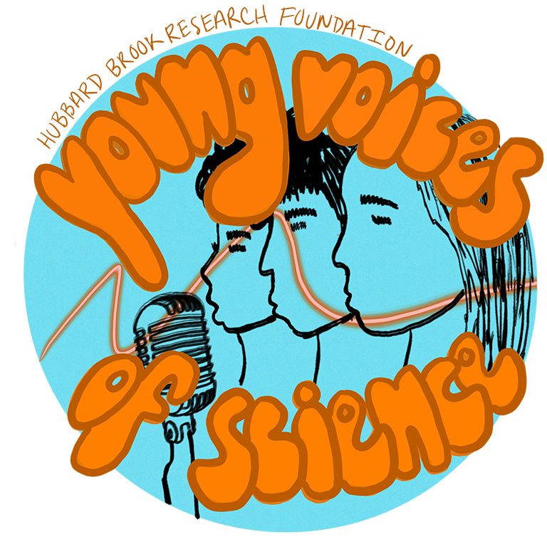

The Hubbard Brook Research Foundation is now accepting applications for our fall 2022 cohort of the Young Voices of Science program.

This FREE program consists of a series of expert-led workshops, each designed to prepare and empower science scholars to share their knowledge, concerns, and hopes for the future with the wider world. We provide participants with a launch pad for public engagement, early in their scientific careers.

Our workshop leaders are experts in public engagement with science, creative writing, storytelling, and science-to-policy outreach. Class size is limited to 20 participants; we ask that participants commit to all seven workshops and design and carry out at least one outreach activity, with support from a staff mentor.

**Young Voices of Science Program- Fall 2022**

**- What:** FREE science communication training and real-world practice for science scholars!

**- Who:** Graduate and undergraduate students in environmental fields are eligible to apply

**- When:** Series of seven Zoom workshops held on Thursdays, October 6th through November 17th, 6:00 - 7:30 pm ET

**- Where:** Wherever you are, via Zoom!

Class size is limited **– apply by September 23rd!**

**Click** [**HERE**](https://docs.google.com/forms/d/1MYZu2VL1f4urXdCo7FI8uWpJQE3oKk2m3WKs_NHWMf0/edit) **to apply for the Fall 2022 Young Voices of Science Program!!**

**For more on the Young Voices of Science program, application links and contact information, visit us at** [**https://youngvoicesofscience.org/**](https://youngvoicesofscience.org/)

**----------------------------------------------------------------------------------------------------------------------------------**