

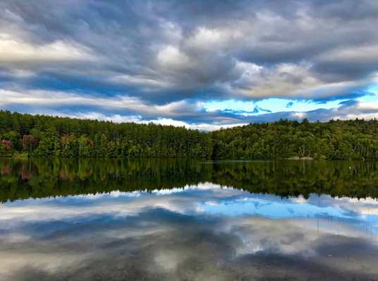

*Mirror Lake – Jane Sokolow*

**! SAVE THE DATES !**

for the

**Hubbard Brook Annual Cooperators’ Meeting – July 13 - 14, 2022**

and the

**Quarterly Project Meeting – July 15, 2022**

to be held at

**Merrill Place Conference Center, Plymouth State University\***

with **field trips** at **Hubbard Brook Experimental Forest**

and **social gatherings** at **Pleasant View Farm**

*on-site affordable lodging available

**Please mark your calendars—details to follow.**