Dear Hubbard Brook Community,

We are happy to announce a “request for participation” in the Hubbard Brook Long Term Ecological Research (LTER) renewal proposal. As part of the NSF LTER program, we are required to submit new proposals every six years. The next one is due in March 2022. We have been working on this proposal as a group since January of 2021 and a writing team has been working to synthesize our group discussions. We have exchanged ideas about novel and surprising findings that have emerged from our long-term research that motivate questions that can only be addressed with further long-term research. We have discussed the mix of activities: monitoring, experiments, modeling, and sampling campaigns, that we might pursue to address these questions. And we have articulated overarching, cross-cutting questions to drive synthesis and integration questions across different components of the project.

Now we are asking for specific ideas for how individuals would like to participate in the new Hubbard Brook LTER proposal and research. What ongoing or new activities would you like to continue? How much would this cost? We are NOT asking for lengthy, detailed proposals and budgets. Rather we are hoping for 1 -2 pages to describe the activities you are proposing, some justification for these activities, and a rough six year budget (March 2023 – February 2029). Please send your 1-2 pages to Peter and Pam by June 15, 2021.

Please keep in mind the following as you prepare your 1-2 pages. Proposals that include components of the Hubbard Brook Ecosystem Study described below are more likely to be selected for inclusion in the new LTER proposal. Submission does not guarantee that your proposed ideas will be in the new LTER proposal, but we will do our best to be as inclusive as possible.

1. 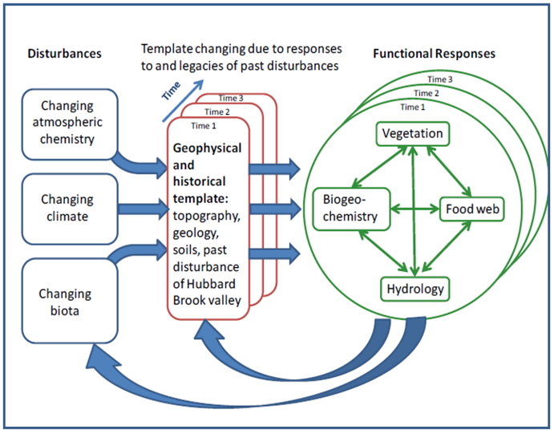**Our conceptual model.** Research in the Hubbard Brook LTER project is driven by a conceptual model that focuses on three dynamic drivers (changing atmospheric chemistry, climate, and biota) that interact with a geophysical and historical template to produce functional responses in biogeochemistry, vegetation, food webs, and hydrology. For our new proposal, we are considering modifying this model slightly to focus on spatial and temporal “control points of change”, i.e., particular places or times in the geophysical and historical template that might be key to significant long-term change in the structure and/or function of the ecosystem at Hubbard Brook.
2. **Our themes and subthemes.** The conceptual model contains four themes (changing atmospheric chemistry, climate, biota, and the geophysical and historical template) that we will embed across the detailed components of the proposal. The themes and sub-themes from the current LTER project are listed below, as well as a few very tentative possible new sub-themes (*in italics*). We are considering putting the “template” theme first given our new focus on “control points of change” in our conceptual model. Please consider how your proposed research might fit into these areas. Suggestions for modifications to the new sub-themes, or different sub-themes are welcome.
   1. Theme 1 – Changing Atmospheric chemistry (with sub-themes):
      1. Controls on nitrogen availability and losses from forests
      2. Multiple element limitation
      3. *Carbon:nitrogen:climate interactions*
      4. *Phosphorus*
      5. *Deacidification as a driver of ecological change*
      6. *Nitrogen oligotrophication as driven by changes in CO2, N deposition, deacidification, and growing season length*
   2. Theme 2 – Changing climate (with sub-themes):
      1. Changes in evapotranspiration: Response to climate variability and forest disturbance
      2. Changing seasonality (Three subprojects – phenology, spring trigger, streams)
      3. Climate change effects on N cycling
      4. Climate change, N availability, and forest food webs
      5. *Changes in variance as a driver of ecological change*
      6. *Increases in precipitation*
      7. *Changes in winter climate*
   3. Theme 3 – Changing biota (with sub-themes):
      1. Vegetation dynamics.
      2. The incipient loss of Fraxinus from HBR
      3. Changing stream food webs
      4. *The role of structure in forests*
      5. *Distinguishing ecological versus evolutional change in ecological communities*
      6. *Species additions and removals as driver of change (e.g. changing abundance of bats, ash trees, oaks, ticks etc)*
      7. *The emergence of novel communities*
   4. Theme 4 – Geophysical and historical template (with subthemes):
      1. Hydropedologic research: Validating and extending the model of hydrology and soil formation
      2. Characteristics of headwater and seasonal streams
      3. Spatial patterns of animal populations
      4. *Terrestrial stream interactions*
      5. *Resilience and tipping points?*
3. **New ideas about convergent research, the interface between science and society, diversity, equity, and inclusion.** Think about how your ideas for participation facilitate integration between basic science, application to pressing societal questions (e.g. education, outreach, and/or solution-oriented research), and opportunities for increasing diversity, equity, and inclusion among participants and stakeholders in our project.

1. **Overarching questions to drive synthesis and integration.** In the current LTER project, we have five overarching, cross-cutting questions that drive synthesis and integration across different components of the project. The questions from our last proposal are listed below, as well as several very tentative possible new questions (in italics) that might be included in the new proposal. Please consider how your research might contribute to these questions. Suggestions for modifications to the new questions, or different questions are welcome.
   1. How will legacies of past air pollution, particularly depletion of exchangeable cations and accumulation of organic matter, S and N in the soil, affect the future structure and functioning of forest and stream ecosystems?
   2. What are the soil, microbial and vegetation processes that have permitted N export in stream water in the reference watershed to remain low despite continued N pollution and cessation of biomass accumulation in the watershed forest?
   3. How will simultaneous and interactive effects of climate change, air pollution, plant succession, and invasive species alter the structure, function and biodiversity of the future forests of HBR?
   4. How will changing climate seasonality, particularly changes in spring snowmelt, soil thawing, and phenology of microbes, plants and animals, affect ecosystem functions and food webs?
   5. Is N availability a key driver that integrates microbial, plant and animal population dynamics?
   6. *How are changes in the carbon cycle driven by increases in atmospheric CO2 and a longer growing season affecting nitrogen and phosphorus availability? How are these effects mediated by deacidification, pH thresholds, mycorrhizae, change in the forest floor, hydropedological variation in oxygen, iron, and other elements?*
   7. *Will the water cycle constrain the ability of forests to exploit a longer growing season and increased atmospheric CO2? Are we seeing more growing season drought and water limitation of forests in a region with high, and increasing precipitation?*
   8. *Can we use resilience or other topics such as “trees” or “water” or “streams” as boundary spanning points of departure for engaging with and diversifying our group of stakeholders?*
   9. *Are there hotspots or hot moments of natural selection pressure that catalyze the importance of evolution as a driver of ecosystem response to environmental change? Can we distinguish between ecological versus evolutional change in ecological communities?*
   10. *Are there specific locations in the Hubbard Brook landscape that are potential control points for ecosystem change? Are their places where a physical disturbance might unleash a cascade of changes from soil conditions to vegetation, to organic matter quality, to biodiversity? Are these control points driven by historical, physical (e.g., bedrock constrictions), chemical (areas of high pH), or biological (e.g., debris or beaver dams) phenomena? How do these spatial patterns interact with temporal events, i.e., are there specific places that interact with specific times in a functionally important way?*
   11. *How do changes in forest canopy structure, resulting from natural disturbances and compositional shifts, translate into changes in forest ecosystem function, especially fluxes of water and carbon?*
   12. *Is decreasing nitrogen deposition in conjunction with rising plant demand for N and consequent N oligotrophication causing a shift from forest P limitation back towards N limitation? Can a long-term, full factorial N and P addition experiment help to reveal the mechanisms underlying such a shift (e.g., nutrient conservation mechanisms, adjustment of uptake, soil microbial, recycling) and how it varies across the complex terrain of northeastern montane forests?*