**Project title:** Dynamic forest-stream interactions: experimental acceleration of late-successional stream functions and resistance to flood disturbance

**Preliminary list of participants:**

William Keeton, University of Vermont

Dominik Thom, University of Vermont

Dana Warren, Oregon State University

Heather Bechtold, Lock Haven University

Scott Bailey, USFS Northern Research Station

Peter Groffman, CUNY Advanced Science Research Center at Brooklyn College, Cary Institute of Ecosystem Studies

Emma Rosi, Cary Institute of Ecosystem Studies

Christopher Woodall, USFS Northern Research Station

**Abstract**

Secondary forested landscapes in the northeastern U.S. continue to recover from 19th century clearing and other land uses. With the majority of these forests still in a mature developmental condition, there are important questions about how forest processes and ecosystems will change as stands develop towards a late-successional condition. It remains poorly understand how stand development processes will interact with anthropogenic stressors and fine to intermediate-scaled disturbances, including wind and ice storms, that accelerate gap formation and patch diversification. And further, as gap-forming disturbances accelerate stand development, an important question becomes whether recovering late-successional forests will generate a different mix of ecosystem services (e.g., hydrologic regulation and water quality) compared to the younger, structurally simpler secondary forests we have today. Stream-side forest systems are an ideal place to explore these questions based on our previous work on riparian forests in the region. The findings will have important implications for predicting not only future forest dynamics, but also the associated ecosystem processes and biotic interactions in adjacent aquatic environments. From our earlier work in the few remaining primary (old growth) riparian forests in the eastern U.S., we can hypothesize that stand development and localized disturbances create intriguing and beneficial forest-stream interactions, including enhanced nutrient uptake and retention by stream biota, complex shifts in food webs and biological production, and potential increases in flood resistance related to woody debris inputs and channel roughness. Effects on streams of gap creation associated with invasive pests, including emerald ash borer and hemlock woolly adelgid, remain highly unclear. This is particularly true because spatial scale, species-specific mortality, and recovery dynamics are likely to differ significantly from natural gap formation processes.

We are proposing a new, collaborative, interdisciplinary study at Hubbard Brook. We will experimentally test whether and how complex riparian forest structure – particularly characteristics associated with late-successional development (canopy gap formation and large woody material recruitment) – influence stream ecosystem functions through effects on stream light and temperature, in-stream productivity and nutrient dynamics, as well as changes in channel geomorphic features and hydrology that relate to flood resistance in forested landscapes. We will address both theoretical questions about controls on productivity in streams and practical questions about how management promoting late-successional characteristics in the riparian zone will influence aquatic ecosystems and flood resistance.

We focus here on two controls on stream processes related to the structure and development of surrounding riparian forests: light availability and large wood loading in streams. Neither nutrient limitation nor top-down controls on primary production manifest when light is limiting. Therefore understanding controls on light dynamics and their influence on stream metabolism and Gross Primary Productivity (GPP) is of fundamental importance in understanding how nutrients and consumers function in stream ecosystems. We are particularly interested in how changes in forest structural dynamics influence light, and therefore we propose the creation of experimental canopy gaps (scaled on natural gap sizes and frequencies based on previous work) along selected stream reaches at Hubbard Brook. Forested streams are widely acknowledged to be light-limited ecosystems. Previous studies have demonstrated that removal of all riparian vegetation changes stream ecosystem function, but the more complex question of how canopy gaps and associated hotspots of high light and concomitant elevated benthic GPP translate to whole ecosystem processes remains poorly understood.

We also propose manipulating wood loading in the selected stream reaches through direct wood additions to levels commensurate with those documented in the region’s remaining old-growth forests. Wood loading has been shown to affect nutrient processing in streams, with retention and uptake increasing with greater wood levels in some cases. However, other studies have produced contradictory results, suggesting a key knowledge gap in relating wood loading to nutrient dynamics in eastern forest streams. Manipulations that explore mechanistic processes may help to determine factors driving different responses to wood addition and removal. And beyond wood alone, the critical interaction of light and wood loading – both expected to increase with late-successional structural development along stream reaches based on our previous work – in controlling in-stream nutrient processes have never been explored together in a manipulative experimental context, particularly as it relates to the developmental stage of riparian forests. Since wood loading also affects channel geomorphology, including erosional and depositional processes as well as “roughness” coefficients related to dissipation of flood energy and re-infiltration of stream flow in previous research, we will investigate relationships between channel planform adjustments and natural high precipitation events. Other sources of variation in stream processes related to anthropogenic stressors, such as climate change, airborne pollutants, and invasive pests and pathogens, will be addressed statistically and using simulation modeling, building on Hubbard Brook’s extensive datasets. The individual tree-based landscape and disturbance simulator called “iLAND,” recently parameterized and re-calibrated for the U.S. Northeast, will be employed for modeling purposes (see list of supporting papers).

Our proposed study will bring together two lines of previous research (see list of supporting papers) in which our group has participated: namely studies of in-stream processes and channel geomorphology in relation to forest age and development; and silvicultural studies in which experimental manipulations has been proven capable of accelerating rates of stand structural development. The former includes both descriptive and experimental work throughout the Northeast, while the latter includes the P.I.’s ongoing 18-year study at two research forests in Vermont. In this study we integrate both with the goal of better understanding forest-stream linkages and how those will change in the future, potentially yielding important ecosystem services. We anticipate the results will inform both our understanding of the basic ecology of forest-stream interactions and critical aquatic ecosystem processes, while also enhancing our ability to predict future shifts in ecosystem service provisioning and resistance to disturbance in relation to forest development and stresses.

We propose a factorial Before-After-Control-Impact experimental design implemented at stream reach scales (roughly 300 linear meters along streams). In this design there will be four factorial treatments: no manipulation, gap creation, wood addition, and gap creation + wood addition. These will be implemented along three replicate reaches per treatment. Forest manipulations will extend to a distance equivalent to three site potential tree heights on either side of stream channels, which is the distance over which forest canopies have been shown to most strongly regulate below-canopy microclimate and low angle light attenuation in previous research.

We are in the early stages of project design. Therefore, we propose implementing this study in two stages. In stage one (6 months to 1 year), we will invite potential collaborators, broaden the team of terrestrial and aquatic ecologists with relevant expertise and interests (including modeling), conduct design and planning workshops, and engage stakeholders around goal development. The latter is particularly important to ensure stakeholder input and the public’s engagement with the science throughout the project, including initial design. We will also make final site matching and selection decisions from candidate reaches in north-facing and western portions of the experimental forest during the first stage, determining also the level of feasible treatment replication. In stage two, the experimental manipulations will be implemented. Intensive sampling is planned for both forest attributes and in-stream processes over two growing seasons pre-treatment and at least three seasons post-treatment. A wide array of stream process response variables will be of interest to the investigators, and we propose focusing these through the planning process in stage one.

**Hypotheses**

1. Accelerated late-successional forest structural development will result in alterations of stream productivity, nutrient processing, and channel complexity.
2. Enhanced wood loading will correlate with increased in-stream nutrient retention and uptake rates as new dams retain fresh organic material and increase hypohreic flowpath length. As wood jams age and accumulate inorganic sediment and organic material with lower C:N ratios, their function in stream nutrient retention will decline.
3. Canopy gaps will alter localized stream light availability, which will lead to greater primary production and greater nutrient demand. This will lead to areas of the stream under canopy gaps that will also have a larger standing stock (biomass) of periphyton and invertebrates in mid-summer than the control reaches with more uniform and closed riparian forest canopies.
4. The strongest nutrient and productivity responses will occur where both light is not limiting and wood additions result in the highest nutrient processing rates.
5. Wood additions will result in greater channel geomorphic complexity and in-stream structures (e.g. debris dams, bank deposits, pools, etc.) that will in turn increase channel roughness.
6. Increased roughness and channel complexity will reduce rates of planform adjustment in response to high precipitation events.

**Design overview:**

1. **Building on previous research; design workshop following the Kellogg process**



Figure from: Warren, Keeton, et al. 2016. Ecosphere.

1. **Replicated BACI design along 12 stream reaches at HBEF**

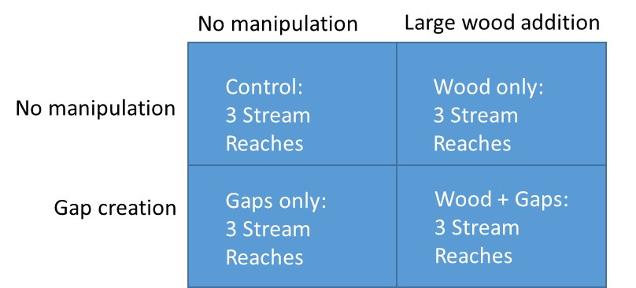

1. **Upscaling using the iLand model**



Figure from: Seidl et al. 2012. Ecological Modeling; Thom et al. 2017. Ecological Monographs

**Potential study reaches:**

* Minimum of 8 reaches (2 replicates per treatment); ideally 12 reaches (3 replicates per treatment)
* Mid elevation, hardwood dominated, previously un-manipulated
* Perennial 1st and 2nd order streams
* Northern and southeast facing watersheds in the western portion of HBEF
* Controls could include reaches above W7 and W8.
* Potential to manipulation reach above W7, depending on interest and coordination with HBEF community of scientists
* Each study reach (i.e. replicate) would be 300 meters of stream channel length by approximately 200 – 300 meters on each side of channel, depending on site potential tree height. Option to standardize or reduce widths of manipulated areas.

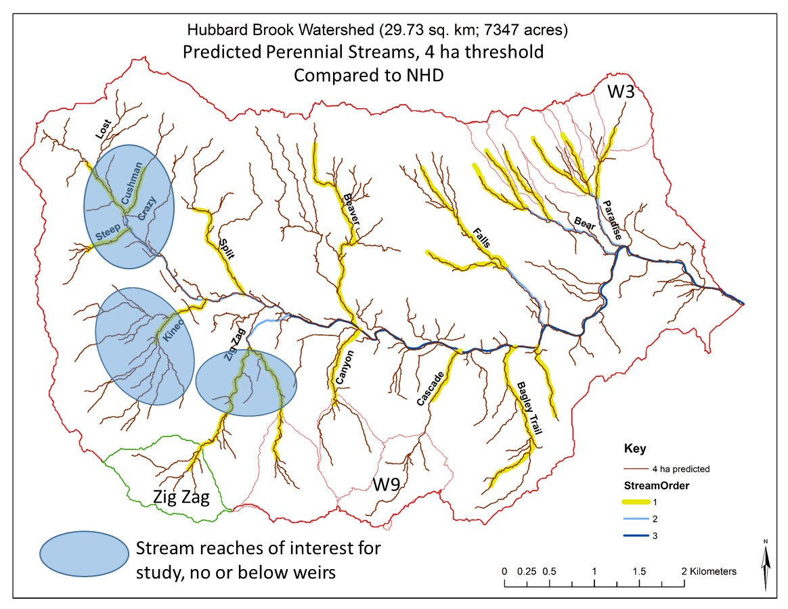

**Preliminary timeline:**

* **Fall 2018.** Design workshop with invited collaborators at HBEF or UVM. Expand and refine experimental design; incorporate pre-existing datasets and participant interests. Finalize site selection. Identify potential funding sources. Outline proposal.
* **Winter 2018-2019.** Proposal writing and submission
* **Summers 2019 & 2020.** Pre-treatment sampling
* **Late summer 2020.** Treatment implementation
* **Summer 2021.** First year of post-treatment data collection

**Potential Funding Sources:**

* National Science Foundation, Division of Environmental Biology, [Ecosystem Science Cluster](https://www.nsf.gov/funding/pgm_summ.jsp?pims_id=503663&org=NSF).
* National Science Foundation, [Dynamics of Coupled Natural and Human Systems](https://www.nsf.gov/funding/pgm_summ.jsp?pims_id=13681&org=DEB).
* Northeastern States Research Cooperative (pending renewal of the program in FY19)
* USDA McIntire-Stennis Forest Research Program
* USDA, National Institute of Food and Agriculture, Agriculture and Food Research Initiative, [Foundational and Applied Science Program](https://nifa.usda.gov/funding-opportunity/agriculture-and-food-research-initiative-foundational-applied-science-program)

**Selected supporting references:**

***Silviculture for late-successional forest characteristics –***

Keeton, W.S., C. Lorimer, B. Palik, and F. Doyon. 2018. Silviculture for old-growth in the context of global change. *Chapter 13* *in:* Barton, A. and W.S. Keeton (eds.). Ecology and Recovery of Eastern Old-Growth Forests. Island Press, Washington, D.C. 288 pp.

Fahey, R.T., B. C. Alvesherea, J.I. Burton, A.W. D'Amato, Y.L. Dickinson, W.S. Keeton, C.C. Kerne, A.J. Larson, B.J. Palik, K.J. Puettmann, M.R. Saunders, C.R. Webster, J.W. Atkins, C.M. Gough, and B.S. Hardimani. 2018. Shifting conceptions of complexity in forest management and silviculture. Forest Ecology and Management 421: 59-71.

Urbano, A.R. and W.S. Keeton. 2017. Forest structural development, carbon dynamics, and co-varying habitat characteristics as influenced by land-use history and reforestation approach. Forest Ecology and Management. 392: 21–35

Ford, S.E. and W.S. Keeton. 2017. Enhanced carbon storage through management for old-growth characteristics in northern hardwoods. Ecosphere 8:1-20.

Gottesman, A. and W.S. Keeton. 2017. Regeneration responses to management for old-growth characteristics in northern hardwood-conifer forests. Forests 8 (45): 1-21.

Kern, C. C., J. Burton, P. Raymond, A. D’Amato, W.S. Keeton, A.A. Royo, M.B. Walters, C.R. Webster, and J.L. Willis. 2016. Challenges facing gap-based silviculture and possible solutions for mesic northern forests in North America. Forestry 90: 4-17.

Dove, N.C and W.S. Keeton. 2015. Structural complexity enhancement increases fungi diversity in northern hardwood forests. Fungal Ecology 13: 181-192.

Smith, K.J., W.S. Keeton, M. Twery, and D. Tobi. 2008. Understory plant response to alternative forestry practices in northern hardwood-conifer forests. Canadian Journal of Forest Research 38:1-17.

Keeton, W.S. 2006. Managing for late-successional/old-growth characteristics in northern hardwood-conifer forests. Forest Ecology and Management 235: 129-142.

McKenny, H.C., W.S. Keeton, and T.M. Donovan. 2006. Effects of structural complexity enhancement on eastern red-backed salamander (*Plethodon cinereus*) populations in northern hardwood forests. Forest Ecology and Management 230: 186-196.

***Forest-stream interactions and gap processes in late-successsional northern hardwood forests –***

Warren, D.R., W.S. Keeton, H.A. Bechtold, and C.E. Kraft. Stream ecosystems in eastern old-growth forests. 2018. *Chapter 9 in:* Barton, A. and W.S. Keeton (eds.). Ecology and Recovery of Eastern Old-Growth Forests. Island Press, Washington, D.C. 288 pp.

Keeton, W.S., E. M. Copeland, and M.C. Watzin. 2017. Towards flood resilience: exploring linkages between riparian forest structure and geomorphic condition in northeastern U.S. streams. Canadian Journal of Forest Research 47: 476–487

Bechtold, H.A., E.J., Rosi-Marshall, D.R. Warren, W.S. Keeton, and J.J. Cole. 2016. Forest age influences in-stream ecosystem processes in Northeastern US. Ecosystems.

Warren, D.R., W.S. Keeton, P. M. Kiffney, M.J. Kaylor, H.A. Bechtold, and John Magee. 2016. Changing forests—changing streams: riparian forest stand development and ecosystem function in temperate headwaters. Ecosphere 7(8): 1-19.

Curzon, M.T. and W.S. Keeton. 2010. Spatial characteristics of canopy disturbances in riparian old-growth hemlock-northern hardwood forests, Adirondack Mountains, New York, USA. Canadian Journal of Forest Research 40:13-25.

Stovall, J., W.S. Keeton, and C.E. Kraft. 2009. Forest-stream interactions: Fine-scale spatial variability in late-successional riparian forests structure, light, and periphyton abundance. Canadian Journal of Forest Research 29: 2343-2354.

Warren, D.R., C.E. Kraft, W.S. Keeton, J.S. Nunery, and G.E. Likens. 2009. Dynamics of wood recruitment in streams of the northeastern U.S. Forest Ecology and Management 58:804-813.

Keeton, W.S., C.E. Kraft, and D.R. Warren. 2007. Mature and old-growth riparian forests: structure, dynamics, and effects on Adirondack stream habitats. Ecological Applications 17: 852-868.

***iLand model structure and sub-modules –***

Seidl, R., Rammer, W., Scheller, R.M., Spies, T.A., 2012a. An individual-based process model to simulate landscape-scale forest ecosystem dynamics. Ecol. Modell. 231, 87–100.

Seidl, R., Spies, T.A., Rammer, W., Steel, E.A., Pabst, R.J., Olsen, K., 2012b. Multi-scale drivers of spatial variation in old-growth forest carbon density disentangled with Lidar and an individual-based landscape model. Ecosystems 15, 1321–1335.

Thom, D, Rammer, W, Seidl, R, 2017. The impact of future forest dynamics on climate: Interactive effects of changing vegetation and disturbance regimes. Ecol. Monogr. 87: 665-684.

Rammer, W., Seidl, R., 2015. Coupling human and natural systems: Simulating adaptive management agents in dynamically changing forest landscapes. Glob. Environ. Chang. 35, 475–485.

Seidl, R, Rammer, W, Blennow, K, 2014. Simulating wind disturbance impacts on forest landscapes: Tree-level heterogeneity matters. Environ. Model. Softw. 51, 1–11.

***iLand application examples –***

Thom, D., Rammer, W., Dirnböck, T., Müller, J., Kobler, J., Katzensteiner, K., Helm, N., Seidl, R., 2017b. The impacts of climate change and disturbance on spatio-temporal trajectories of biodiversity in a temperate forest landscape. J. Appl. Ecol. 54, 28–38.

Thom, D., Rammer, W., Seidl, R., 2017a. Disturbances catalyze the adaptation of forest ecosystems to changing climate conditions. Glob. Chang. Biol. 23, 269–282.

Thom, D, Rammer, W, Garstenauer, R, and Seidl, R (accepted): Legacies of past land use have a stronger effect on forest carbon exchange than future climate change in a temperate forest landscape, Biogeosciences, <https://doi.org/10.5194/bg-2018-145>