FREE Public Lecture:

Our Dynamic Sun: Space Weather and Vermont

By Dr. Carrie Black
Sponsored by SHINE (shinecon.org), a NSF workshop

Come see ultra high definition videos of the most powerful explosions in the solar system with Dr. Carrie Black, National Science Foundation Postdoctoral Research Fellow at NASA Goddard Space Flight Center and Stowe High School Alumna.
She will show you the surprising culprit - our very own star, the ever-changing dynamic sun. Learn why there is weather in space and how it affects life in Vermont.
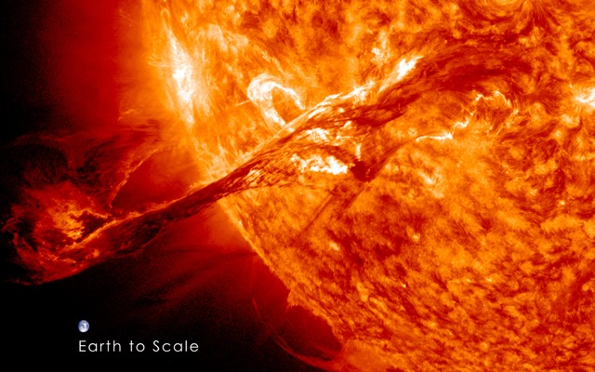
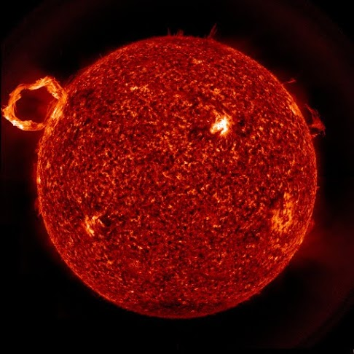

Helen Day Art Center
90 Pond St. Stowe, VT
Wednesday, July 8, 2015
5:45pm

