Plot Treatment Analysis
Plot Map
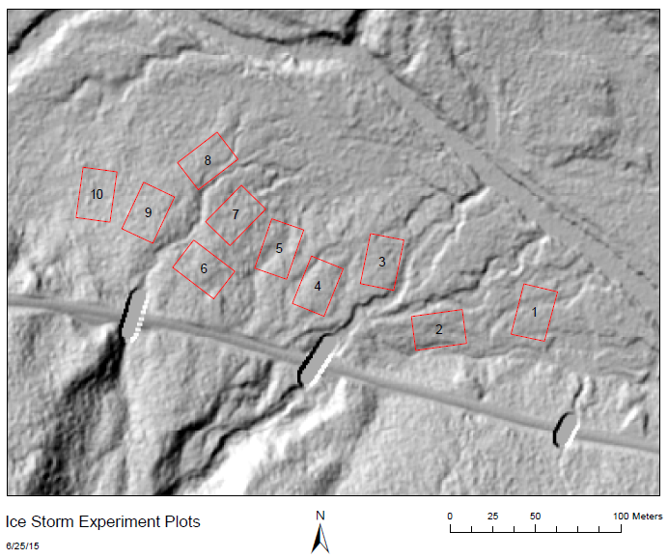

Soil Respiration

No outliers in terms of overall average CO2 flux, but plots 6 and 8 seem to have a slightly different pattern over time from the rest. Plot 6 (orange) peaks earlier than other plots and has a more steady respiration decline, and plot 8 (black) is more erratic.

Vegetation

Plot area is generally a sugar maple stand, with significant populations of red maple and yellow birch, and American beech in the understory. Except for plots 4 and 7, each plot has at least 3 D/CD or large I sugar maples inside or within 1 meter of the inner plots. Each plot also has at least 1 D/CD red maple and yellow birch except for plot 6. Although some plots have more of one species than another, the rest have the required number of each species. Therefore I would conclude that plots 1, 2, 3, 5, 8, 9, and 10 are “typical”, while 4, 6 and 7 are not.

Lysimeter Chemistry
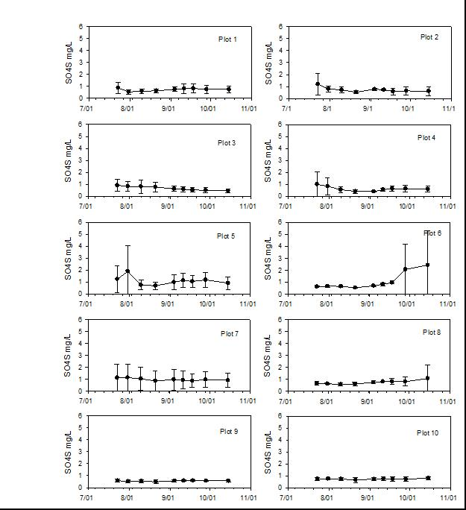

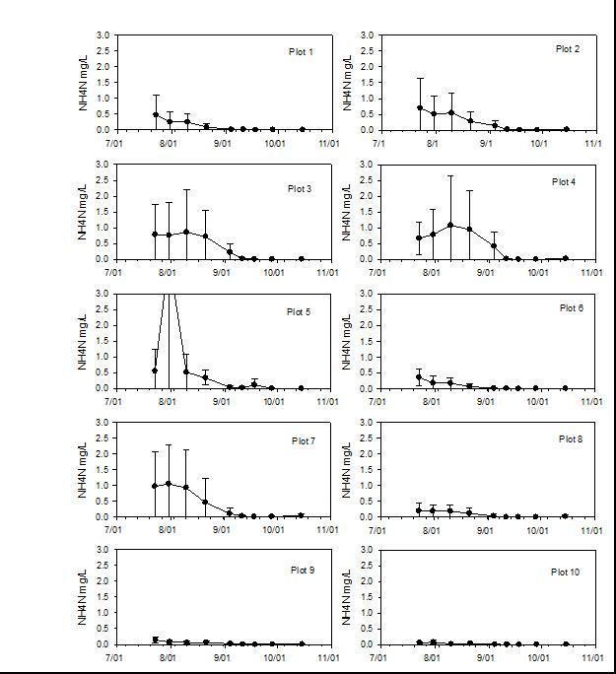

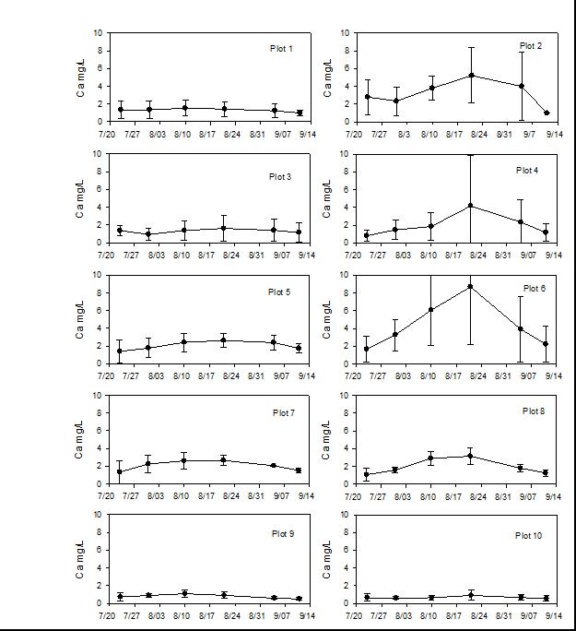For water volumes: Plots2 and 6 generally have 2 lysimeters each that do not collect enough water to sample even after being reinstalled.

Soil Profiles
Plot 1: Soils lack E horizon, though several pits have lighter patches or speckles in the A showing spodic development. Pits on the northern or eastern side of the plot generally have cobble or gravel in the B horizons
Plot 2: Soils very rocky. Spodic with strong E development, would characterize as Bhs podzols, most pits showed thin Bh horizon as well.
Plot 3: Soils less rocky. Most have an E horizon, but one pit only had intermittent E/speckles in A. Several pits showed redox features in B horizons, indicating fluctuating water table. Several pits contained Bs horizons in addition to Bhs.
Plot 4: E horizons present but generally thin/intermittent. Pits contained a mix of all 3 major spodic B horizons. Several pits contained gravel/cobble
Plot 5: All soils spodic, though several only had lighter patches in A horizon. Most pits contained gravel/fine gravel in B horizons, and a couple pits had Bh horizons
Plot 6: Soils rocky, with much more pronounced pit/mount topography than other plots. Soils are strongly spodic following Bh-Bhs development pattern. One pit is located on side of large mound, showing disturbed bimodal development with 2 E horizons.
Plot 7: Soils mostly spodic, with some gravel or cobble in some pits. E horizons vary pit to pit, with one pit only having some very small speckling in A horizon.
Plot 8: Soils vary from east – west. The eastern side of the plot is close to a small stream and contains soils that are more saturated and no spodic, with more silty textures, grey colors and less B horizon development. Southern and western pits were drying with more typical loamy sand/sandy loam textures, though only one pit was spodic.
Plot 9: Typically spodic soils, with E horizons varying between thick – patchy. Some horizons show redox features or other mottling of colors.
Plot 10: Except for 2 pits, soils show no spodic development. Soils are more saturated and silty or loamy in texture. Area seems more swampy than rest of plots.

Extractable NO3 and NH4

N-flux in soil seems to be highly variable between plots and N type. Plots 3, 8 and 10 have very low NO2/NO3, while 6 and 7 are very high. While NH4 seems to be more consistent, Plot 8 has low NH4. This sampling has only been measured once however, and only on fresh cores, not the incubated cores. More data will be available later in the year.

Soil Temperature + Moisture
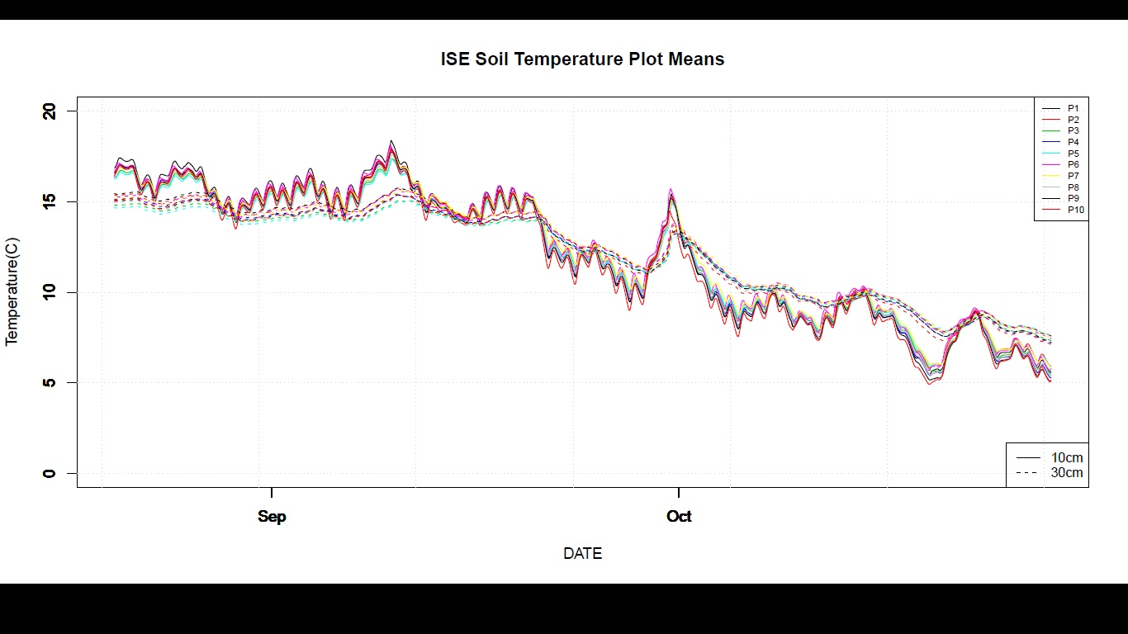
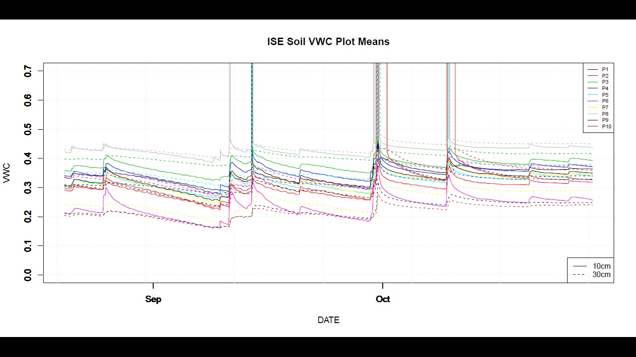
To summarize: All plots seem to follow same general pattern for both temperature and moisture. Temperatures all are fairly consistent across the plots – no real outliers
Moisture is more variable – plots are evenly split between 10cm or 30cm depth containing more moisture, probably due to soil type and location on slope. No obvious outliers, but plot 2 is generally drier than average, while plots 3 and 8 have more moisture.
Other Comments/Concerns
Plot 2 is rockier than most other plots
Plot 6 is much higher up/farther away from Hubbard Brook and closer to the road than the other plots, and is rocky with lots of pit/mound topography
Plot 8 has a large clearing next to its northern border and is in the riparian zone of a small stream
Plot 10 is close to a swampy area, and is generally much more saturated during storm events than other plots, with the water table actually pushing up lysimeter tubes and damaging them – although the sensors do not seem to confirm this

Overall
Plot | Soil Resp | Soil Profile | Soil Temp, Moisture | Vegetation | Extractable  N | Lysimeter Chem | Other
1 | X | X | X | X | X | X | X
2 | X | X | X | X | X | X
3 | X | X | X | X |  | X | X
4 | X | X | X |  | X | X | X
5 | X | X | X | X | X | X | X
6 | X | X | X
7 | X | X | X |  |  | X | X
8 | X |  | X | X
9 | X | X | X | X | X | X | X
10 | X |  | X | X |  | X
‘X’ indicates “Typical”

