Open House/Free to the Public/Rain or Shine
Celebrating
60 Years of Research and Discovery at
Hubbard Brook Experimental Forest

When: Saturday, October 10th, 2015
Time: 10:00 am to 2:00 pm
Place: Hubbard Brook Experimental Forest, 234 Mirror Lake Road, Woodstock NH
Schedule:
- 10:00 to 11:30 - Forest Tours, Tree Climbing, Talk-to-a-Scientist, Children’s Games, Book Signings, Arts, and Music
- 11:30 to Noon – Celebration Speakers
Dr. John Brissette (Assistant Director, Northern Research Station): The Hubbard Brook Experimental Forest as a ‘Gem’ of USDA Forest Service R&D
Dr. Gene Likens (President Emeritus, Cary Institute for Ecosystem Studies): The Contributions of the Hubbard Brook Experimental Forest to Ecosystem Science
Dr. Kathy Fallon Lambert (Director, Science Policy Exchange, Harvard University): The Contributions of the Hubbard Brook Experimental Forest to Science Policy and the Public
Xavier Cortada (Artist, Florida International University): Presentation of Artwork - Hubbard Brook 60th Commemorative Banner
- Noon to 12:30 – Barbeque and Birthday Cake
- 12:30 to 2:00 - Forest Tours, Tree Climbing, Talk-to-a-Scientist, Children’s Games, Book Signings, Arts, and Music
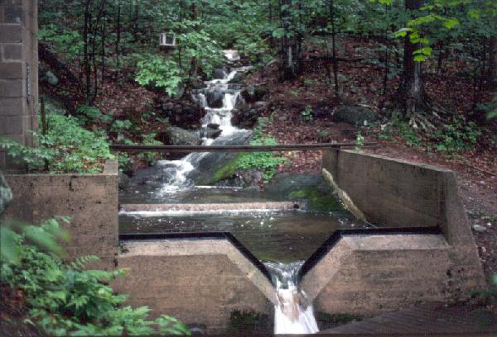

For more information, call:
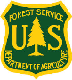
603 726 8902

