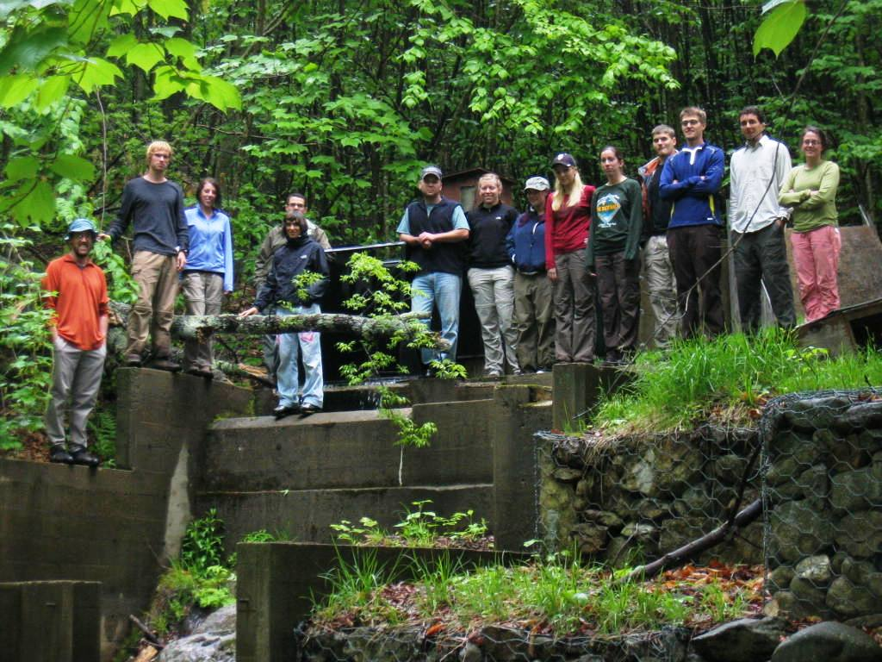
A Summer Research Experience at
Hubbard Brook Experimental Forest:
Investigating and Communicating Change in Ecosystems

Nine undergraduates will live and work at the Hubbard Brook Experimental Forest in the White Mountains of New Hampshire for a 10-week, National Science Foundation sponsored program emphasizing both research and public outreach on topics concerning Northern Hardwood Forest ecosystems.

Research areas include:
Ecosystem Services | Stream Invertebrates
Hydrology | Biogeochemistry
Soils | Plant Ecology
Research projects will be conducted under the supervision of research mentors active at the Hubbard Brook Experimental Forest/LTER site.
Outreach activities will focus on environmental policy, informal science education, and secondary education, through case-studies and weekly workshops led by scientists and professionals active in science outreach, as well as REU-student led outreach to local students.
Dates: May 27 through August 5, 2014 (10 weeks)
Eligibility: Undergraduate freshmen, sophomores, juniors, or first semester seniors. Applicants must be citizens or permanent residents of the U.S. or its possessions.
Stipend: $5000 and free housing.
To apply: Visit www.hubbardbrookreu.org Applications are due Friday, February 6.
